Z SIGHT
Geolocation Fields — Spec Sheet
Field definitions and the geofence-violation evaluation flow — including the Manual Override requirement
Draft · July 9, 2026 · updates §8.4 of the Unified System Specification

1. Purpose
This sheet defines the geolocation fields on a monitor record and how they combine to detect geofence violations.
- Current Reading is nullable — and often null. A device report only carries a GPS fix when satellite coverage allows. A report without a fix is normal operation, not an error.
- Calculated/Smoothed Location is a distinct field. A narrower, stabilized point computed over recent valid fixes, used to smooth out the swings in individual readings.
- Geofence violations are determined from the Calculated Location, with a raw fallback. The smoothed point is the preferred observation. When no stable Calculated Location exists (too few fixes after an install or a long outage), the latest Current Reading is used as the observation instead, flagged as lower confidence — the check still runs rather than going dark.

2. Field Definitions
Field | What it is | Source | Updates | Can it be null? | Used for
Ref 0 — Address Reference | Geocoded coordinates of the service address. | Google geocoding at container-record creation. Provided by ZTERS | Static; re-geocoded only if the address changes. | No — a record should not exist without it. | Pre-install expectation; install validation; last-resort reference.
Ref 1 — Install Reference | The installer's mobile GPS position at activation. | Mobile app, captured during F1 (mount and activate). | Set once per install. | Only if capture failed at install. | Default reference from install until Ref 2 exists; install validation.
Ref 2 — Stabilized Device Reference | Long-window average of where the device lives (DEMA over the last ~100 readings). | Calculated from device fixes. | Recalculated as new fixes arrive; first available after ~100 readings (~30 days). | Yes — null until enough history exists. | The long-term expectation: default active reference once available.
Current Reading | The latest raw GPS fix from the device. | Device report. | Only when a report carries a fix. | Yes — often. A fix requires satellite coverage; many reports carry none. Null is normal, not an error. | Feeds the smoothing calculation; serves as the fallback observation for violation checks when no stable Calculated Location exists (lower confidence).
Calculated / Smoothed Location | A narrower stabilized point over recent valid fixes; smooths out swings in individual readings. | Calculated from recent Current Readings (short window). | On each new valid fix; holds its last value between fixes; goes stale if fixes stop. | Yes — null until a minimum number of fixes exists; can be stale. | The observation: the preferred input for geofence-violation checks (Current Reading is the fallback when this is unavailable).
Manual Override — Manual Reference | A manually entered expected geocoordinate for the monitor. | Authorized user action in Z SIGHT, with reason code. | Set, changed, or cleared explicitly; never displaced automatically. | Yes — exists only while a user has set one. | Highest-priority expectation while active. Ref 2 keeps calculating in the background but does not replace it.
Active Geofence Reference | Derived pointer to the best available expectation. | Priority rule: Manual Override if active, else Ref 2 if valid, else Ref 1, else Ref 0. | Whenever its inputs change. | Only if no references exist at all (data-quality review). | The expectation side of every violation comparison.

3. The Two Smoothed Points — Expectation vs Observation
Ref 2 and the Calculated Location are both smoothed averages of device fixes, and it is easy to confuse them. They differ in window and in job:
 | Ref 2 — Stabilized Device Reference | Calculated / Smoothed Location
Window | Long (~100 readings, roughly a month). | Short (recent fixes only).
Question it answers | Where does this device live? | Where is this device right now?
Role in the comparison | The expectation (the anchor). | The observation (the thing tested).
Behavior when the device moves | Barely moves — that is the point. A relocated device drags Ref 2 slowly. | Follows the move within a few fixes, without whipsawing on any single noisy reading.

A geofence violation is: distance(observation, Active Reference) > movement threshold — where the observation is the Calculated Location when available, else the latest Current Reading (raw fallback, lower confidence). Observation vs expectation.

4. Active Reference Selection
Active Reference = Manual Override if active; else Ref 2 if it exists and is valid; else Ref 1 if it exists; else Ref 0

Manual Override rules (required feature)
- Set by explicit, intentional user action only —latitude/longitude
- While active, it outranks every system-generated reference. Ref 2 continues calculating in the background but never displaces the override automatically.
- It remains active until explicitly cleared
- Typical uses: Ref 0 and Ref 1 weren’t sufficient to eliminate false positive geofence notifications and the location is visible via satellite imagery. Manually adjust to clear notifications.

General rules
- All reference points are preserved with history (coordinate, source, created date, status).
- References are only updated as needed.

5. Violation Evaluation Flow
Runs on every device report.
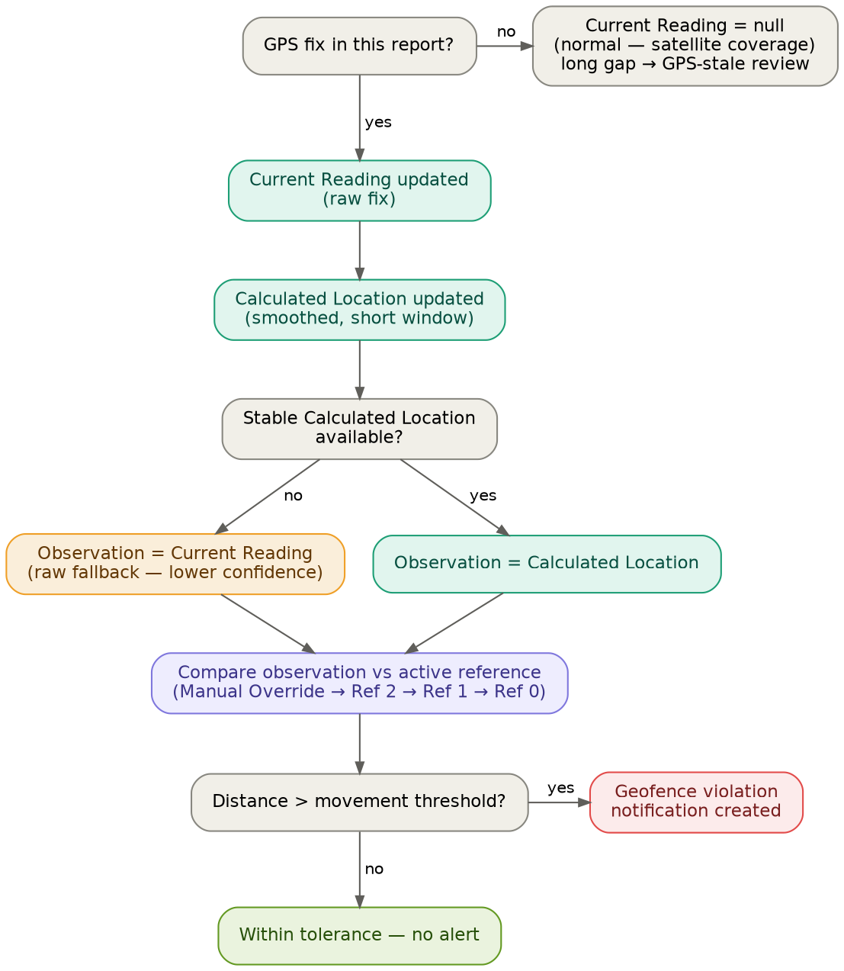
- A device report arrives. If it carries no GPS fix (no satellite coverage), the Current Reading is simply not updated for this report — normal operation, nothing fires. A prolonged gap raises a GPS-stale review (§6), never a movement alert.
- A valid fix updates the Current Reading (raw) and feeds the Calculated Location (smoothed, short window).
- The observation is the Calculated Location when a stable one exists. If it does not (new install, or reset after a long outage), the latest Current Reading serves as the observation instead — flagged lower confidence, but the check still runs.
- Compare the observation against the Active Reference (Manual Override → Ref 2 → Ref 1 → Ref 0).
- Distance beyond the movement threshold → geofence violation notification. Within tolerance → nothing.

6. Null and Staleness Rules
Condition | Rule
Report without a fix | Current Reading is not updated; no alert of any kind. Null-fix reports are expected — satellite coverage decides.
Between fixes | The Calculated Location holds its last value with its timestamp. It does not decay or drift on its own.
No valid fix for N days (configurable) | Mark the Calculated Location stale: suppress movement alerts (a stale point must not fire violations) and raise a GPS-stale data-quality review. Note this is a GPS condition, not 'Unresponsive' — the device may still be reporting images and sensor data normally.
Fewer than M valid fixes (configurable) | No stable Calculated Location yet — the latest Current Reading serves as the fallback observation, flagged lower confidence. Install validation at F1 already covered the install moment.
Single wildly-distant fix (stable Calculated Location exists) | Nothing fires. The raw fix only nudges the smoothed point; a real relocation shows up in the Calculated Location within a few fixes.
Single wildly-distant fix (raw-fallback mode) | The raw fix IS the observation, so it can trigger the comparison. Mitigation options — a wider threshold or a consecutive-evaluation requirement in fallback mode — are open item 7.

